Geometry: Unit 5, Lesson 6
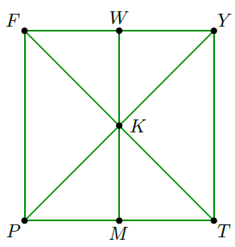
- Quadrilateral $FYTP$ is shown, where $K$ is the midpoint of segments $\overline{FT}$and $\overline{PY}$. What conclusion can be made from the given information and the diagram?

$∠FKP≅∠TKY$, $\overline{FK}≅\overline{TK}$, and $\overline{PK}≅ \overline{YK}$, therefore $∆FKP≅∆TKY$

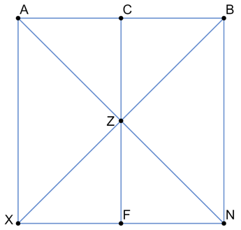

- Quadrilateral $ABNX$ is shown, where $\overline{AB}||\overline{XN}$ and $\overline{AB}≅\overline{XN}$. What conclusion can be made from the given information and the diagram?

$∠BAZ≅∠XNA$ and $∠BZA≅∠XZN$, therefore it can be determined that $∆BZA≅∆XZN$
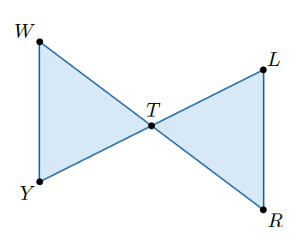
- Triangle $WTY$ and triangle $RTL$ are shown, where $T$ is the midpoint of line segments $WR$ and $LY$. To prove the triangles are congruent, since it is given that $T$ is the midpoint of line segments $WR$ and $LY$, it can be stated that what?

$$\overline{WT}≅\overline{RT}$$

